Automatic identification system

What is AIS?
The automatic identification system (AIS) is an automatic tracking system that uses transponders on ships and is used by vessel traffic services (VTS). When satellites are used to detect AIS signatures, the term Satellite-AIS (S-AIS) is used.

The Universal Shipborne Automatic Identification System (AIS) is a system of transponders installed on vessels which transmit over two dedicated digital marine VHF channels. The data is sent from each vessel every few seconds and contains position and movement information such as course, speed, latitude, longitude, and rate of turn. Static information about the vessel is sent every few minutes and includes the name, type of ship, length, beam, draft, etc. Nearly all commercial ships are mandated to carry AIS transponders and each year more yachts, launches and work boats are fitting AIS equipment.
AIS Transponders: An AIS transponder receives and translates the AIS digital radio signals. It also sends AIS signals, making your vessel visible to others with AIS equipment. There are two types of transponders, Class A intended for SOLAS vessels and Class B for fitting on non-SOLAS category vessels. AIS transponders are sometimes referred to as transceivers in the marine industry.
AIS Receivers: An AIS receiver operates in the same way as transponder but is a receive only device. If your vessel has a receiver you are able to view vessels in your area but other vessels will not see you on their AIS equipment.
AIS Display: An AIS display interfaces with either a transponder or receiver to display the AIS radio signals in a useable format. A dedicated AIS display is very useful to allow critical safety information to always be available at a glance and can include features that aren’t normally found in plotters or computer programs. If the transponder or receiver is WiFi enabled, you are able to use your smart phone, tablet or computer as an AIS display.
AIS Aerial/Splitter: A dedicated AIS aerial is used to pick up and transmit AIS signals only. A AIS/VHF splitter can be installed in order to share an existing VHF aerial between your VHF radio and AIS transponder or receiver.
Automatic identification systems (AIS) are designed to be capable of providing information about the ship to other ships and to coastal authorities automatically.
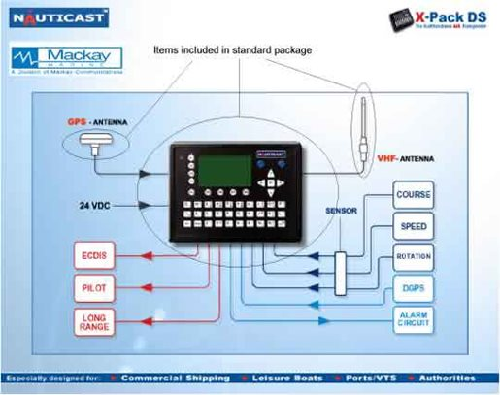

Regulations for carriage of AIS
Regulation 19 of SOLAS Chapter V - Carriage requirements for shipborne navigational systems and equipment - sets out navigational equipment to be carried on board ships, according to ship type. In 2000, IMO adopted a new requirement (as part of a revised new chapter V) for all ships to carry automatic identification systems (AISs) capable of providing information about the ship to other ships and to coastal authorities automatically.
The regulation requires AIS to be fitted aboard all ships of 300 gross tonnage and upwards engaged on international voyages, cargo ships of 500 gross tonnage and upwards not engaged on international voyages and all passenger ships irrespective of size. The requirement became effective for all ships by 31 December 2004.
Ships fitted with AIS shall maintain AIS in operation at all times except where international agreements, rules or standards provide for the protection of navigational information.
A flag State may exempt ships from carrying AISs when ships will be taken permanently out of service within two years after the implementation date. Performance standards for AIS were adopted in 1998.
The regulation requires that AIS shall:
- provide information - including the ship's identity, type, position, course, speed, navigational status and other safety-related information - automatically to appropriately equipped shore stations, other ships and aircraft;
- receive automatically such information from similarly fitted ships; · monitor and track ships;
- exchange data with shore-based facilities.
The regulation applies to ships built on or after 1 July 2002 and to ships engaged on international voyages constructed before 1 July 2002, according to the following timetable:
- passenger ships, not later than 1 July 2003;
- tankers, not later than the first survey for safety equipment on or after 1 July 2003;
- ships, other than passenger ships and tankers, of 50,000 gross tonnage and upwards, not later than 1 July 2004.
An amendment adopted by the Diplomatic Conference on Maritime Security in December 2002 states that, additionally, ships of 300 gross tonnage and upwards but less than 50,000 gross tonnage, are required to fit AIS not later than the first safety equipment survey after 1 July 2004 or by 31 December 2004, whichever occurs earlier. (The original regulation adopted in 2000 exempted these vessels.)

# Who are carrying AIS Equipment?
Every year, more and more vessels are voluntarily installing AIS equipment due to the enormous safety benefits. During the 73rd Session of the IMO's Maritime Safety Committee, the following vessels were identified as requiring AIS equipment as a mandatory requirement.
All ships of 300 gross tonnage and upwards engaged on international voyages and cargo ships of 500 gross tonnage and upwards not engaged on international voyages and passenger ships irrespective of size shall be fitted with AIS, as follows:
- Ships constructed on or after 1 July 2002
- Ships engaged on international voyages constructed before 1 July 2002
- In the case of passenger ships, not later than 1 July 2003
- In the case of tankers, not later than the first "safety equipment survey" after 1 July 2003
- In the case of ships, other than passenger ships and tankers, of 50,000 gross tonnage and upwards, not later than 1 July 2004
- In the case of ships, other than passenger ships and tankers, of 10,000 gross tonnage and upwards but less than 50,000 gross tonnage, not later than 1 July 2005
- In the case of ships, other than passenger ships and tankers, of 3,000 gross tonnage and upwards but less than 10,000 gross tonnage, not later than 1 July 2006
- In the case of ships, other than passenger ships and tankers, of 300 gross tonnage and upwards but less than 3,000 gross tonnage, not later than 1 July 2007

