What is the Difference Between AC Motor and DC Motor?

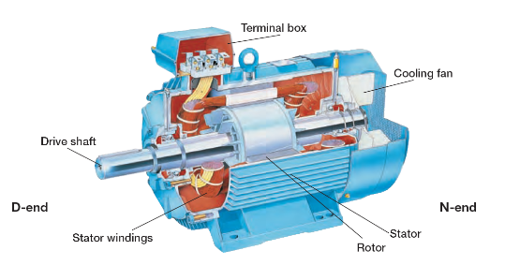
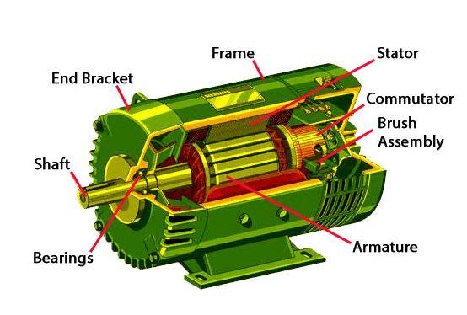
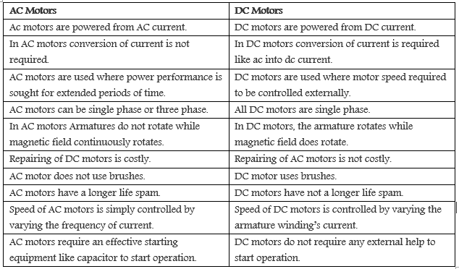
DC motors have the advantage of: higher starting torque, quick starting and stopping, reversing, variable speeds with voltage input and they are easier and cheaper to control than AC. AC motor advantages include: lower power demand on start and minimal maintenance.

