Qs. What is auto pilot system in a ship ?
An autopilot (or pilot) is a mechanical, electrical or hydraulic system which can maintain a vessel on a predetermined (set) course / heading without the need of human intervention. This system reduces work load of navigator, indeed. But only has to maintain a close watch for any malfunctioning ( like:- off-track/ deviation from the desired course line due to strong current or wind effect )

Qs. Autopilot in details?

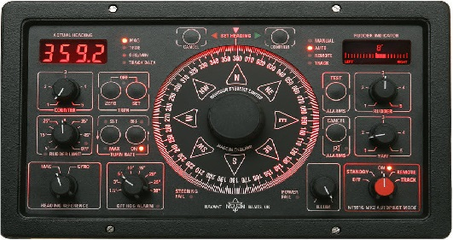

An autopilot (or pilot) is a mechanical, electrical or hydraulic system which can maintain a vessel on a predetermined (set) course without the need for human intervention. Using a direct or indirect connection with a vessel’s steering mechanism, the autopilot relieves the crew from the task of manually steering the ship.

Autopilot system that offer reduced fuel costs and increased transit times by increasing ship’s average speed. These new systems learn the characteristics of the vessel’s handling and minimize rudder movement reducing drag on the vessel. Increased speed and lower fuel consumption makes autopilot more user friendly.

Autopilots do not replace a human operator, but assist them in controlling the ship, allowing them to focus on broader aspects of operation, such as monitoring the trajectory, weather and systems.

- This instrument is not to replace the helmsman.
- It is not to be used in restricted waters/ narrow channel or during manoeuvring.
- Not to be used for large alterations of more than 10 degree
- Autopilot will operate efficiently over a certain speed (approx. > 5 knots), below which it will start to wander(Port~Stbd~Port).
- Autopilot is normally used when ship has to steer same course for long period of time.
- It facilitates navigator to do other additional job.
- Auto pilot system is not appropriate during rough sea.

By: Capt. Taimur

