What do you mean by mechanical stresses in the maritime transport or Ship Motion in Seaway?

Mechanical Stresses or Ship Motion in Seaway:
Ship freely floating is subject to 6 degrees of freedom.

There are two types of ship motions in seaway. These are:
i) Translational or Linear: Motion related to linear distance.
ii) Rotational or Rotatory: Motion related to angular distance.

Three are Translational:
  - Heave (z): Motion along z - axis.
  - Sway (y) ): Motion along y - axis.
  - Surge (x) ): Motion along x - axis.
Three are Rotational:
1. Yaw (z): Motion about z - axis.
2. Pitch (y) : Motion about z - axis.
3. Roll (x) : Motion about z - axis.

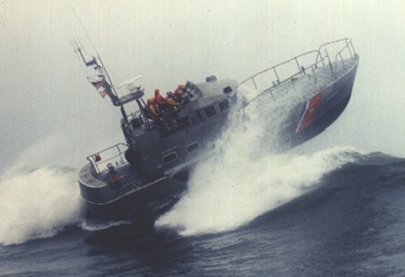

Ship’s Axes and Degrees of Freedom

